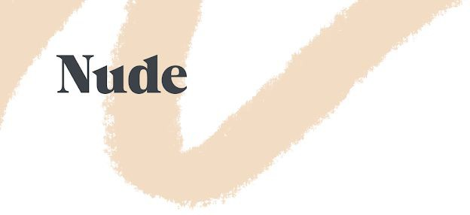

Cancellation Form Nude Finance Limited

We’re sorry you’re thinking of leaving us…
If you’re sure you want to leave, please fill this form out and email a copy of it to hey@getnude.com. You have a right to cancel your account if you change your mind within the first 30 days of opening it.

Your name

Your address

Your National Insurance number

I hereby exercise my right to cancel my account. I request the return of any money I am due under the customer agreement and undertake to pay or repay any sums to which I am not entitled.

Signed

Date

1

